VOIP Network Diagram and Passwords
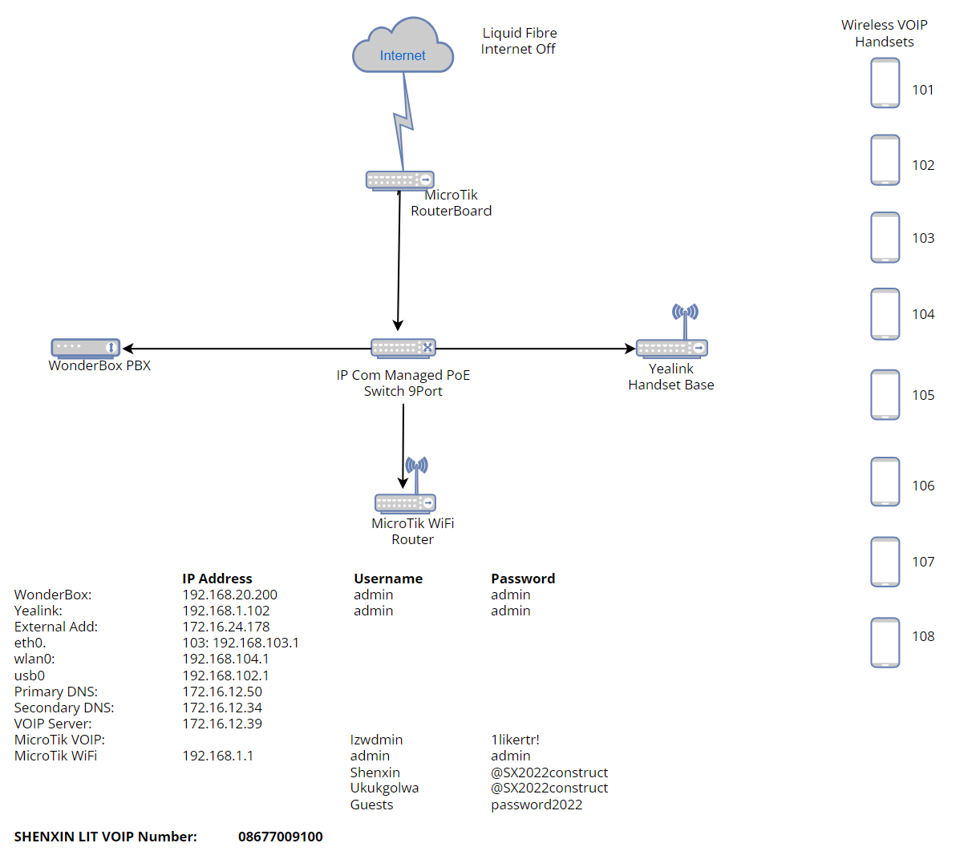

Pin Sets for External Calls
8879 | 8047 | 8604 | 7280 | 7577
8128 | 7454 | 8843 | 7346 | 7806
7797 | 7410 | 8087 | 7681 | 7795
8793 | 7250 | 7212 | 7567 | 7583

